C:\Users\emachines\AppData\Local\Microsoft\Windows\Temporary Internet Files\Content.IE5\PFBL3NHW\MC900030254[1].wmf

Employees standing on chairs are being injured at an alarming rate, **PLEASE us ladders, they are available** to **ALL** employee upon request

* 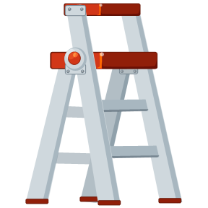When it is necessary to climb---use a ladder, not a chair, stool, desk or box. Be sure the ladder is secured.
* Approved ladders or other safe support should be used to reach materials on high shelves, bulletin boards, or other high elevations.
* Do not reach too high for something that may fall on you

*Make safety the first consideration in every situation!!*

*Proper Lifting Technique:*

1. **Lift close to your body.**
2. **Feet shoulder width apart.**
3. **Bend your knees and keep your back straight.**
4. **Lift with your legs.**

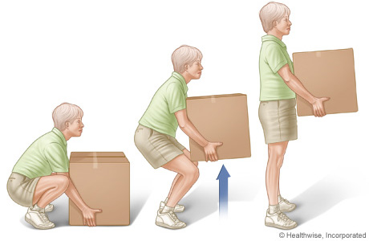

*Always Remember:*

Overloaded sockets can easily cause fires, which could be easily prevented. If too many appliances draw power from one socket it can start overheating and catch fire. C:\Users\emachines\AppData\Local\Microsoft\Windows\Temporary Internet Files\Content.IE5\0CKJVWPC\MC900370856[1].wmf